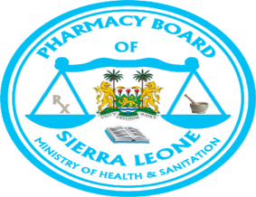

PHARMACY BOARD OF SIERRA LEONE
ALLEGED BLEEDING AND DEATH LINKED TO MEBFIL (MEBENDAZOLE 100mg)

The Pharmacy Board of Sierra Leone (PBSL) has received a suspected adverse drug reaction report of bleeding and death allegedly linked to Mebfil.
As a result of this, PBSL has started an investigation and requested the marketing authorisation holder to recall all Mebfil products from the Sierra Leone market, including all distribution points such as hospitals, wholesalers, pharmacies, drug stores, and patent medicine shops.
The Pharmacy Board of Sierra Leone is currently supervisingthe quarantine of the said product so that no patient or consumer will have access to it pendingthe conclusion of the ongoing investigation.
Therefore all healthcare professionals and the general public are advised not to prescribe, dispense or take Mebfil until the investigation is completed and a formal communication is released by the Pharmacy Board of Sierra Leone, Ministry of Health and Sanitation.

From
Information and Communication Department
Pharmacy Board of Sierra Leone

